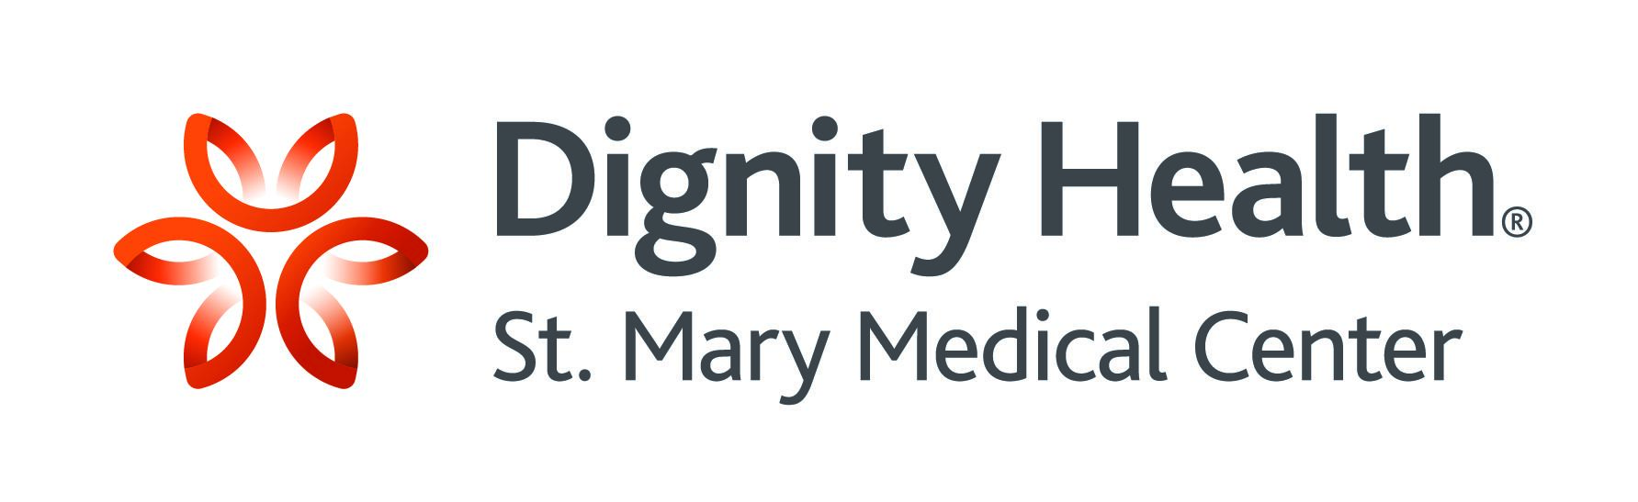

**Spring, 2025**

***St. Mary Physicians’ Appeal***

**The St. Mary Scholar Program**

***Bridging the gap: championing health justice through education & mentorship***

***Health Justice***

St. Mary is a champion for health justice – an ideal that is realized when every person is able to live as healthy a life as she/he is capable of living.

One factor that powerfully impedes health justice is the lack of healthcare professionals, especially physicians. The Association of American Medical Colleges projects a shortage of up to 124,000 physicians by 2034. Locally, the need for more medical doctors is already keenly felt.

**St. Mary Physicians Appeal – A Scholarship at Charles R. Drew University of Medicine and Science**

At the request of the Chief of Medical Staff, Dr. Arlene Vernon, the St. Mary Medical Center Foundation is offering physicians an opportunity to provide a scholarship for a rising medical student at Charles R. Drew University of Medicine and Science.

* Tuition is $50,000, and fees are about $25,000 a year.
* The St. Mary Scholar will be from California and a member of a minority group.
* Charles R. Drew University will award the scholarship, and St. Mary physicians will have an opportunity to form a relationship with the scholarship honoree.



***The St. Mary Scholar Program***

The Physicians’ Appeal is part of The St. Mary Scholar Program – which does several things at once: (1) it directly impacts the current critical shortage of healthcare professionals (2) it opens a door into work that can become a career – if you are a physician, you can find employment anywhere in the country (or the world) (3) for some, this is a road out of poverty (90 percent of medical students at Charles R. Drew University qualify for financial assistance).

St. Mary is already taking a leading role locally in raising up a new generation of healthcare professionals.

* Last spring, the St. Mary Medical Center Foundation created a $2 million endowment, the interest from which supports scholarships for students in local institutions who are preparing for healthcare professions.
* In 2024, St. Mary “jumped into the game” and gave out $2,500 scholarships to ten nursing students at Long Beach City College ($25,000) and $5,000 scholarships to ten nursing students at California State University Long Beach, ($50,000). The Foundation will give additional scholarship awards in 2025.
* The St. Mary Medical Center Foundation is actively raising funds in the community to grow The St. Mary Scholar Program.

**How to Give**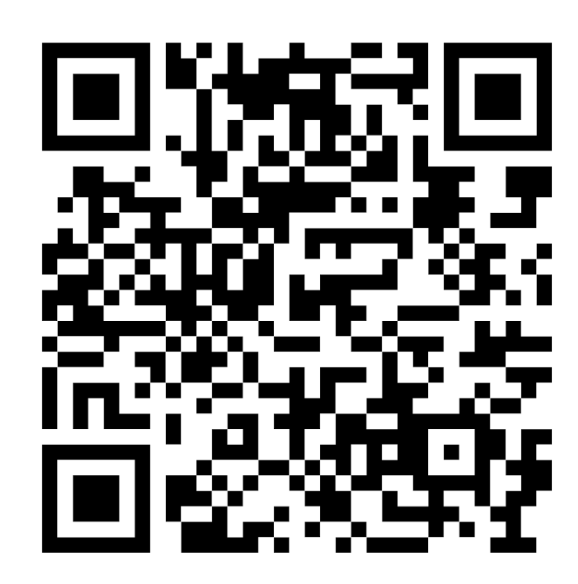

Gifts can be made by check or online. If you want to make a gift of securities, contact St. Mary Chief Philanthropy Officer Michael Neils directly.

* Make your check payable to St. Mary Medical Center Foundation. Mark the memo: Physicians' Appeal. Mail to St. Mary Medical Center Foundation, 1050 Linden Avenue, Long Beach, CA 90813.
* Give online at https://www.supportstmary.org/physiciansappeal
* Use the QR code
* The St. Mary Medical Center Foundation is an IRS approved nonprofit organization EIN 23 - 7153876. Your gift is fully deductible to the extent allowed by law.

If you have questions, contact Dr. Arlene Vernon or Michael Neils (see below).

**St. Mary – your health is our mission, always!**